Multiple Linear Regression in Python - Automatic Backward Elimination

Hi guys,

if you are also interested in some automatic implementations of Backward Elimination in Python, please find two of them below:

**Backward Elimination with p-values only:**

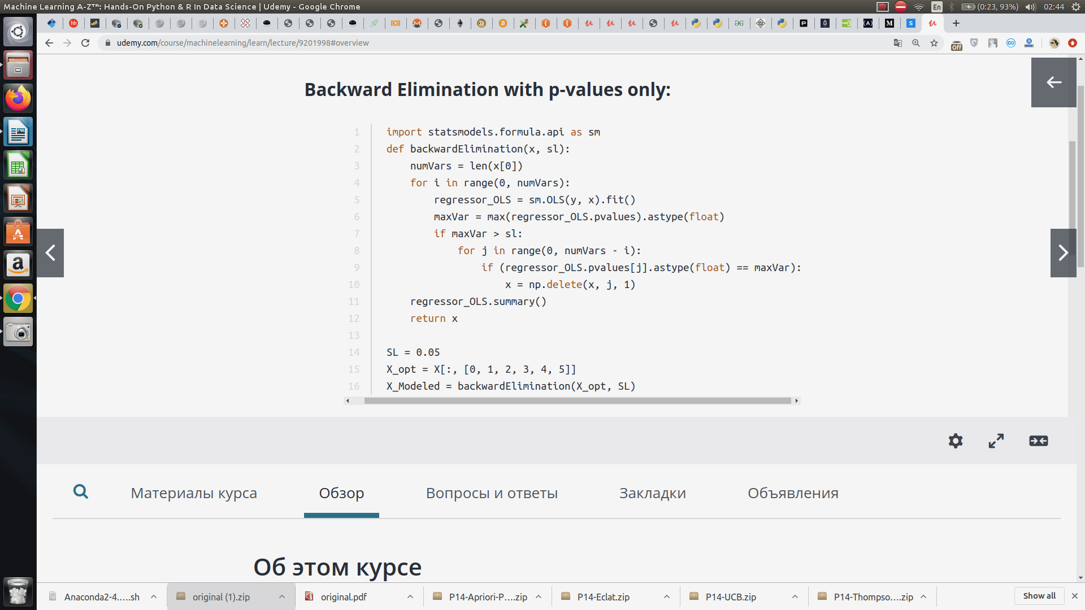

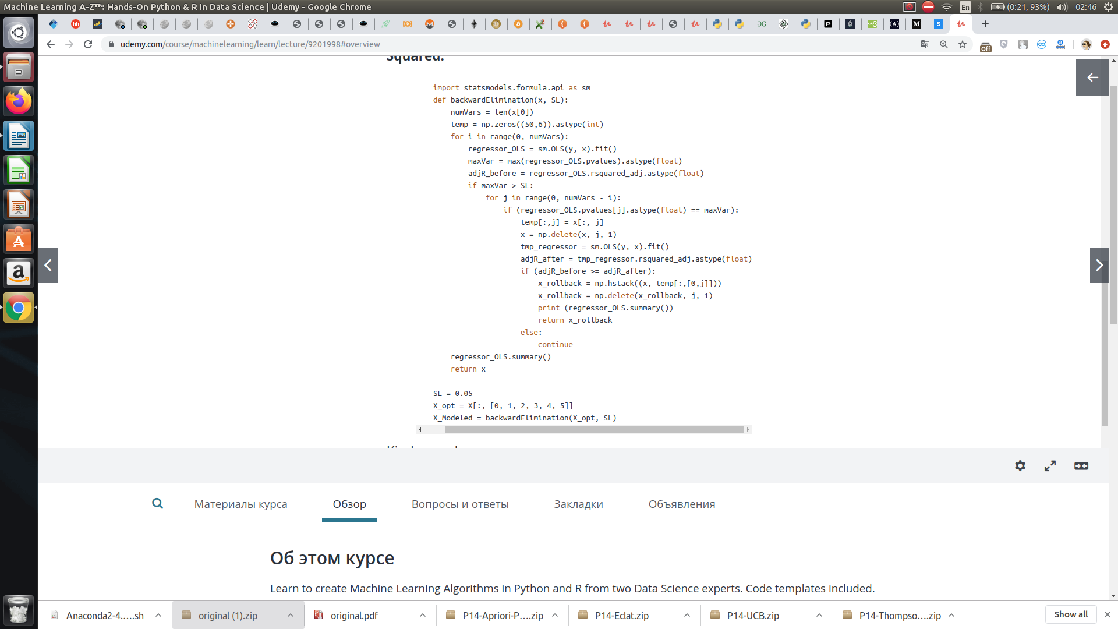**Backward Elimination with p-values and Adjusted R Squared:**